Figuracion, John Glenn F. 25/11/25
3A1-1/BSCS Sir. Edward

  - “DICT,Denial of Service”

According to the DICT, websites and applications may slow down during the "traffic flood".
The Department of Information and Communications Technology (DICT) raised a warning on Sunday, November 2, about a Distributed Denial of Service (DDoS) or “traffic flood”.
It is reportedly happening on November 5.
DICT explained that a DDoS is like a “traffic jam” on the internet brought by multiple hackers trying to access a website or an application.
Users may experience a slowdown in accessing a website or an application.
The DICT reassured that no personal accounts, data, or money will be stolen in the “traffic jam”.

Reaction:
The recent warning issued by the Department of Information and Communications Technology (DICT) regarding a possible Distributed Denial of Service (DDoS) attack on November 5 highlights the growing vulnerability of the country to cyber threats. The DICT’s explanation that a DDoS attack functions like a “traffic jam” on the internet helps ordinary users understand the nature of the risk. While it does not involve stealing personal data or money, the potential slowdown of websites and applications can still significantly disrupt daily activities, especially as many government and private services depend heavily on online platforms.
I believe the DICT’s early warning is a positive step. It shows transparency and preparedness, allowing the public to remain aware rather than alarmed. The assurance that no personal accounts or financial information will be compromised also helps reduce unnecessary panic. However, this situation also underscores a deeper issue: the Philippines needs stronger and more modern cybersecurity infrastructure to defend against increasingly sophisticated attacks.
In my view, this incident should serve as a wake-up call for both the government and the public. Digital security is not only a technical matter—it affects national stability, business operations, and the daily lives of Filipinos. Strengthened cybersecurity must be a national priority moving forward.

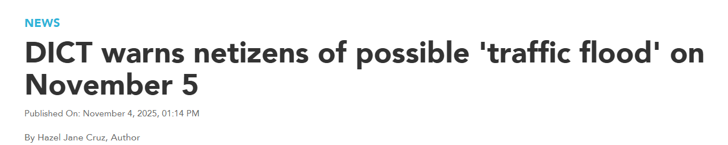
GMA Integrated News. (2025, November 2). DICT warns netizens of possible ‘traffic flood’ on November 5. GMA News Online. https://www.gmanetwork.com/lifestyle/news/127450/dict-warns-netizens-of-possible-traffic-flood-on-november-5/story

